Topic Lectur No 1: ANN

Go to Other Docx in file ANN.docx

What is Regression?
Regression is a type of supervised learning where the goal is to predict a continuous value (a number).
Instead of predicting categories (like spam/not spam), regression predicts values like:
- House price
- Temperature
- Salary
- Stock prices

Types of Regression

1. Linear Regression
Only one independent Variable and one of dependent variable
- Straight-line relationship
- Easy to understand
- Used in:
  - Price prediction
  - Trend analysis
Y=mx+b
Where:
- y = predicted value
- x = input feature
- m = slope (relationship strength)
- b = intercept
Example:
- x = house size
- y = price

How to find the value of m and b:
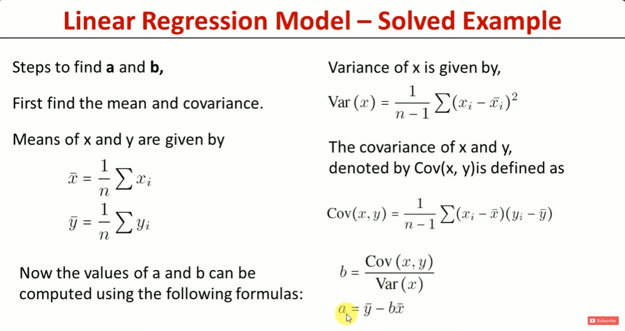
2:
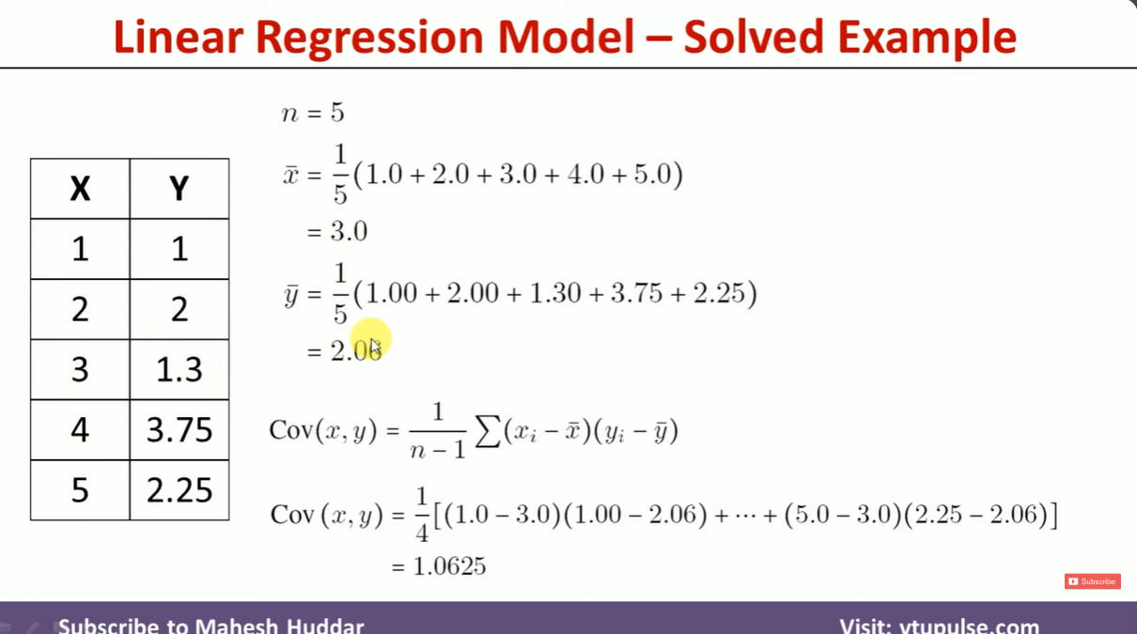
3:

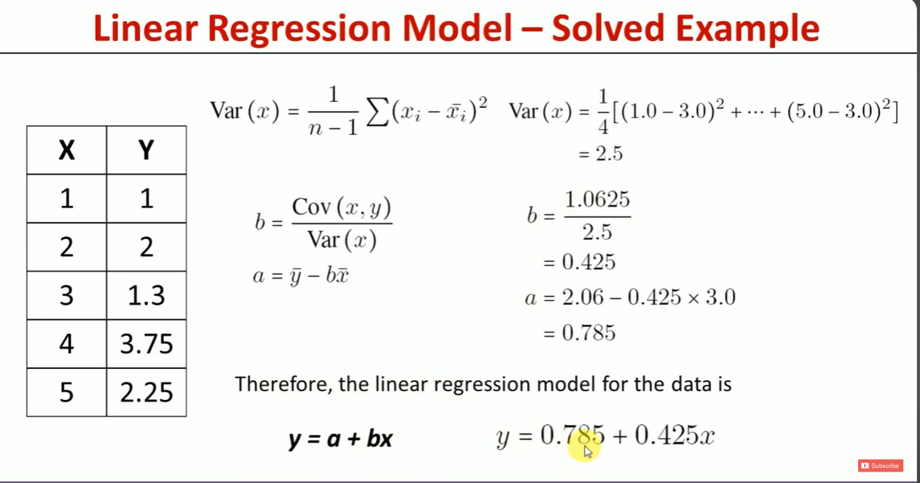
Code:
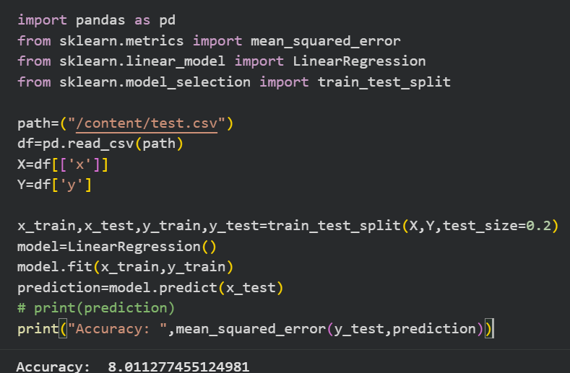
2.Multiple Linear Regression Model
Where are multiple independent variables like x1,x2,x3….Xn and one dependent variable like
( output/Class)
- Uses multiple inputs
Example:
Price = f(size, bedrooms, location)

3. Polynomial Regression
- Handles curved relationships
Example:
- Growth trends
- Complex patterns
y=a_{0*x+} a_{1*x}²₊ a_{2*x}³₊ a_{3*x}⁴₊ …. a^{n}*x^{n}

4. Logistic Regression (Important!)
Despite the name, it’s used for classification, not regression.
Logistic Regression is used when the dependent variable is binary (0/1,True/False, Yes/NO)

^{Lecture No 2:}
^{K-Means Clustring:}
K-Means is used to group similar data.
This is an Unsupervised Learning algorithm.

Numerical

Euclidean Distance Formula
d(A, B) = √((x₁ − x₂)² + (y₁ − y₂)²)

Instance No | Height | Weight
1 | 185 | 72
2 | 170 | 56
3 | 168 | 60
4 | 179 | 68
5 | 182 | 72
6 | 188 | 77
Step-1: Cnetriod Points
Kitny cluster rhkny ha randomly koi bhi choose kr skty ha agr b (K) ki value na di hoi tu agr di hoi ho tu Choose Value Of (K=2)
Decide how many clusters (K) You choose K=2 (two groups). These groups are defined by a central point called a centroid.
K1
H=185
W=72

K2
H=170
W=56

Step 2 — Randomly pick starting centroids
- K1 = Row 1 → (185, 72)
- K2 = Row 2 → (170, 56)
Step-3:
Phr Euclidean Distance formula sy Remaining values ka distance compute krna ha
Jo sab sy choti value aygi us ko hum n us centriod ma rhkna ha
• Distance to K1 = 20.80 (far)
- Distance to K2 = 4.48 (close)

Step 4 — Update the centroid after each new member
New Distance jo aya ha us ka centroid ki value ko update krna ha

Updated Centriod:
K2
H=169
W=58_
K1
H=185
W=72

Kasy Update Krna???
Formula: Old Centriod + New Centriod / TotalValue
Hieght ko bhi krna
Weight Ko b krna
New K2 = average of (170, 56) and (168, 60) = (169, 58)
Step-5: Ans
- K1= {1,4,5,6}
- K2 = {2,3}

